Mô hình mạng:

Kali: 10.3.40.3

Windows 10: 10.3.40.4

Windows Server 2019: 10.3.40.5

Windows Server 2016: 10.3.40.6

Ubuntu: 10.3.40.7

**Module 06: System Hacking**

Lab 1:Gain Access to the System

Task 4: Exploit Client-Side Vulnerbility and Establish a VNC Session

Task 4.1: Create Exploit

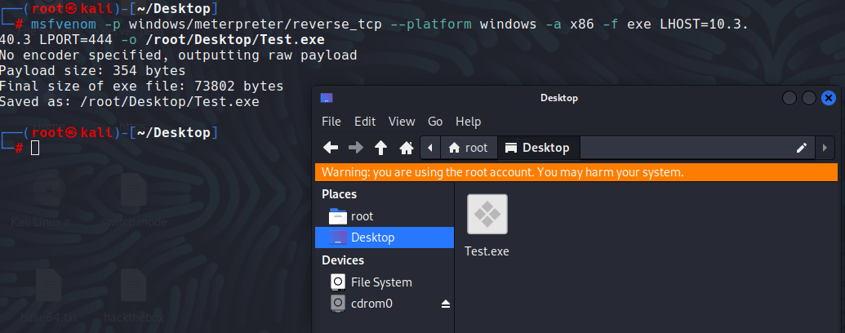

Image 6.1.4.1 Generating malicious exe file

Task 4.2: Create Directory to Share Exploit

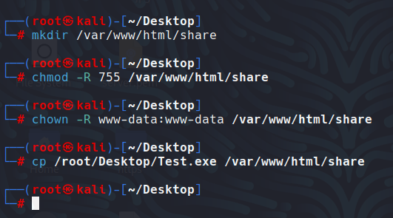

Image 6.1.4.2 Sharing the malicious exe file

Task 4.3: Launch Metasploit

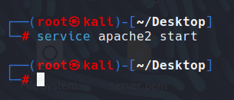

Image 6.1.4.3 Starting the apache service

Task 4.4: Set the Payload

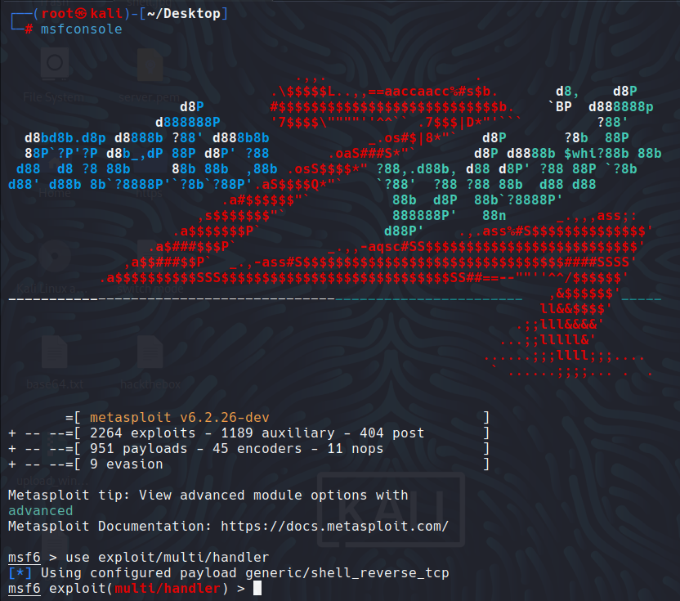

Image 6.1.4.4.1 Setting up a listener

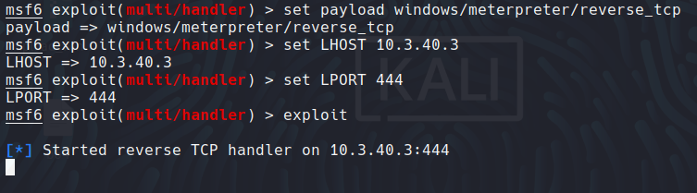

Image 6.1.4.4.2 Starting the listener

Task 4.5: Run Exploit

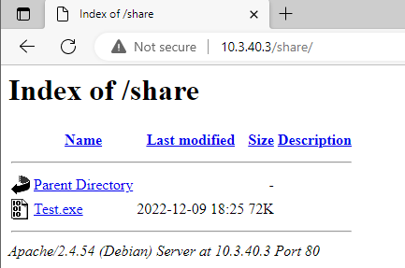

Image 6.1.4.5.1 Malicious exe file in Windows 10

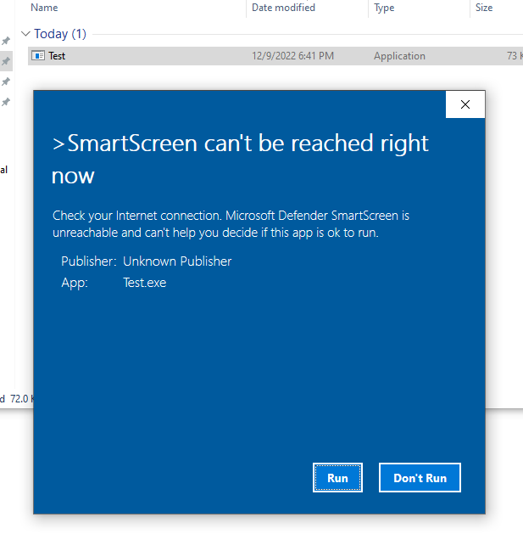

Image 6.1.4.5.2 Download the exe file

Task 4.6: Establish Remote Sesssion

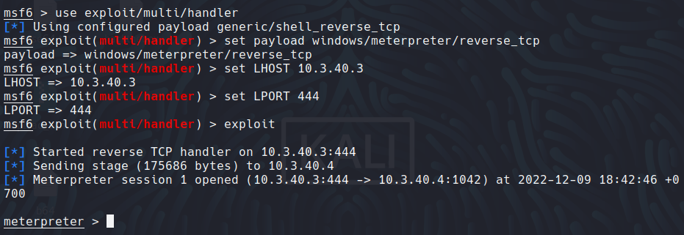

Image 6.1.4.6.1 Meterpreter shell successfully obtained

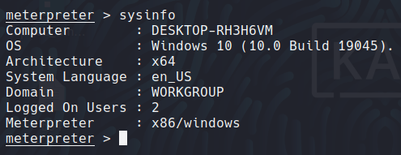

Image 6.1.4.6.2 Windows 7 Remote view in Kali

Task 4.7 Find Misconfigurations in the Target System

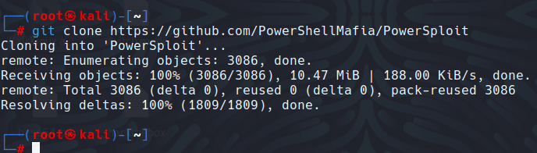

Image 6.1.4.7.1 Cloning PowerSploit

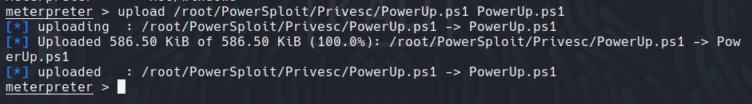

Image 6.1.4.7.2 Upload the file to the target system

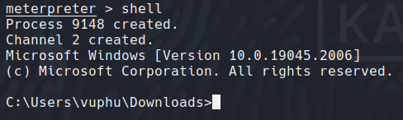

Image 6.1.4.7.3 Upload the file to the target system

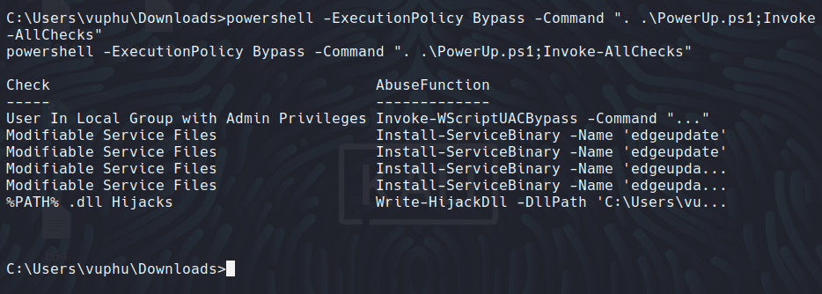

Image 6.1.4.7.4 Potentially hijaclable DLL locations

Task 4.8: Open VNC Session

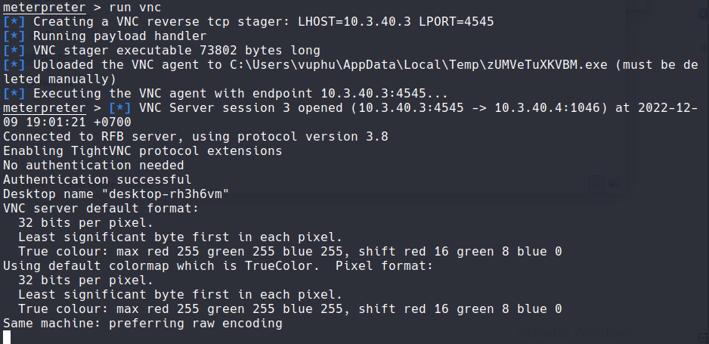

Image 6.1.4.7.5 Opening a VNC session through meterpreter

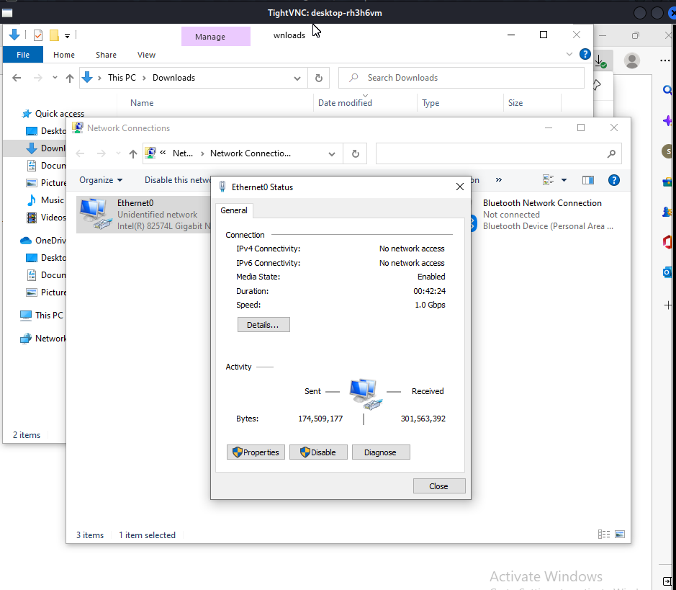

Image 6.1.4.7.6 Victim’s system through a VNC session

Task 7: Perform Buffer Overflow Attack to Gain Access to a Remote System

Task 7.1: Launch Vulnseerver

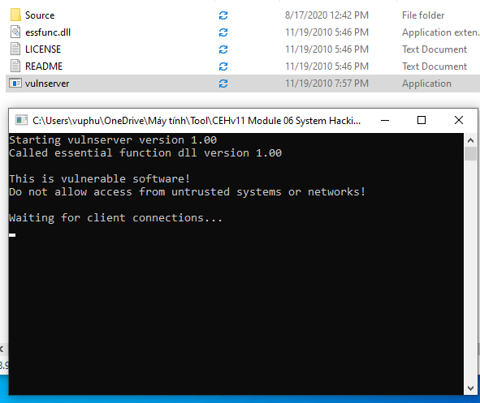

Image 6.1.7.1 Vulserver starts running

Task 7.2 Install Launch Immunity Debugger

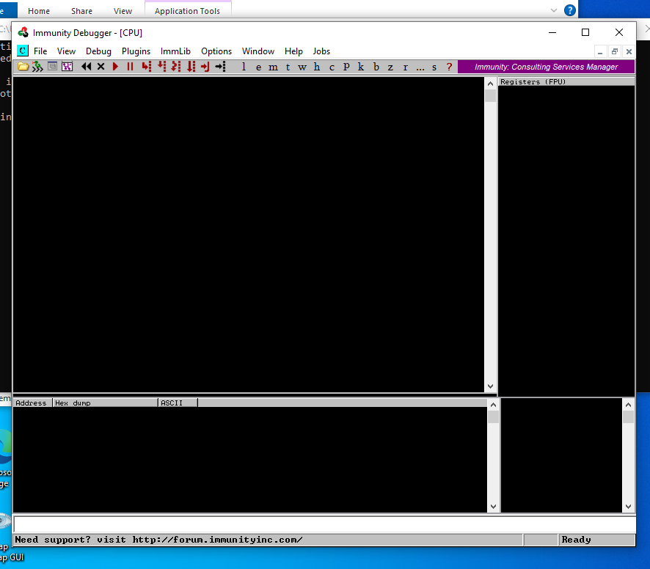

Image 6.1.7.2 Immunity Debugger main window

Task 7.3 Attach and Run Vulserver

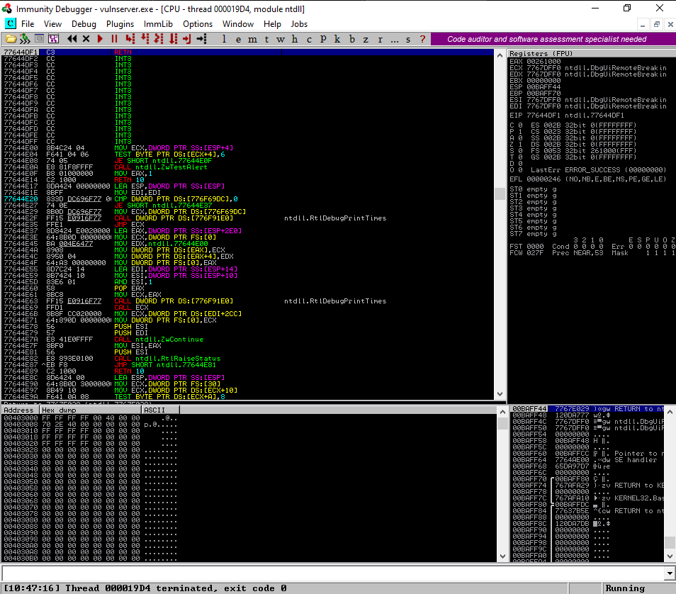

Image 6.1.7.3 Immunity Debugger running

Task 7.4 Perform Spiking

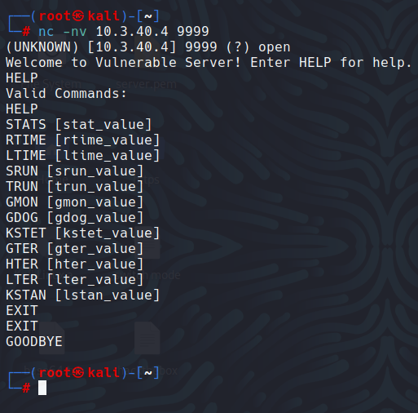

Image 6.1.7.4 .1 Netcat cmd to establish a connection

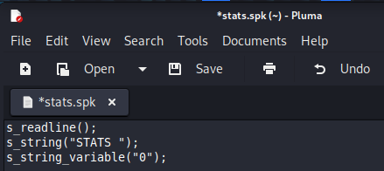

Image 6.1.7.4.2 Write stats.apk script

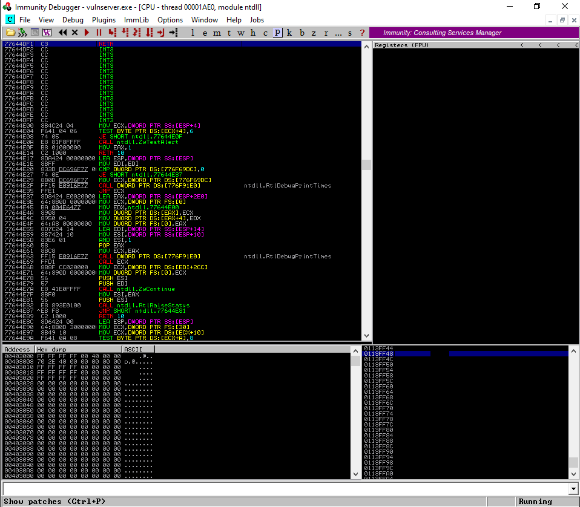

Image 6.1.7.4.3 Immunity Debugger is still running

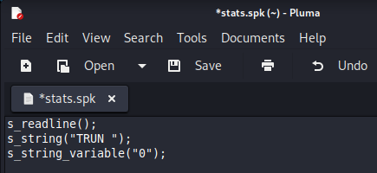

Image 6.1.7.4.4 Create a script file trun.spk

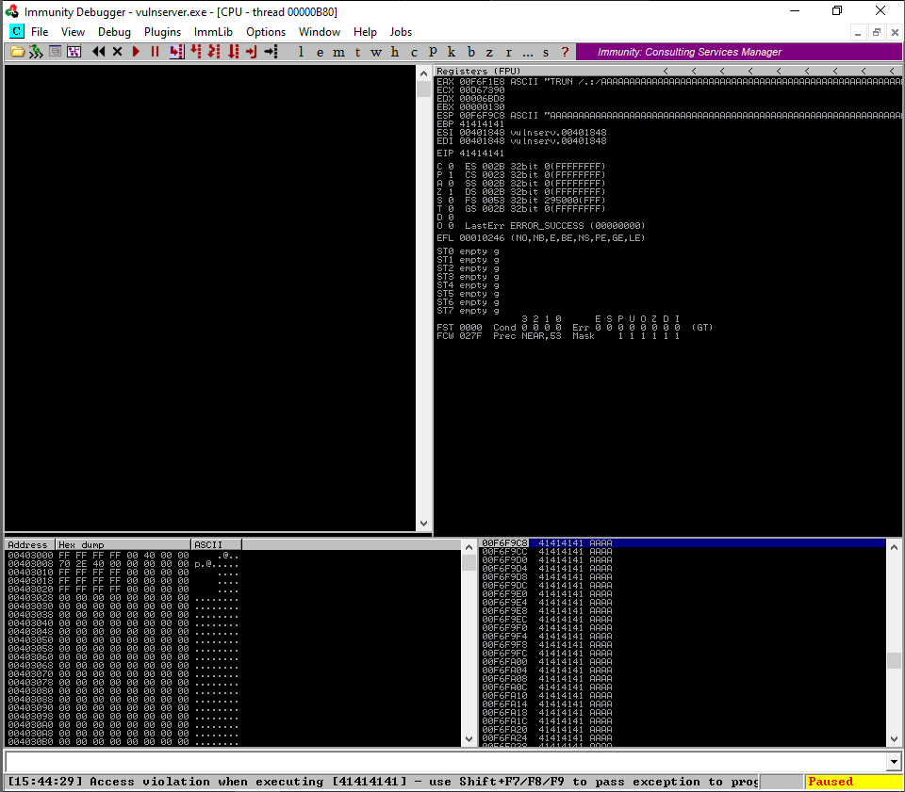

Image 6.1.7.4.5 Immunity Debugger status gets changed to Paused

Task 7.5: Perform Fuzzing

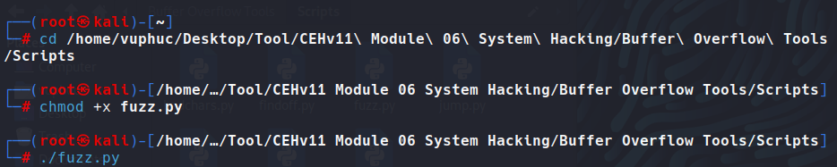

Image 6.1.7.5.1 Run fuzz.py script

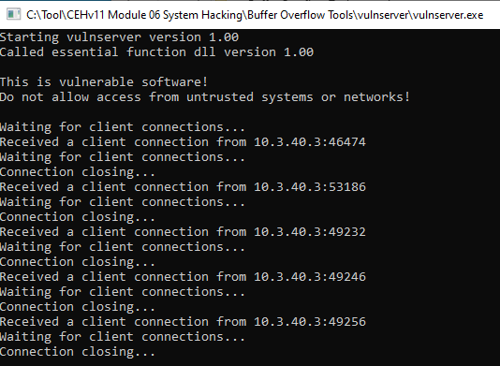

Image 6.1.7.5.2 Connect requests captured by vulnserver

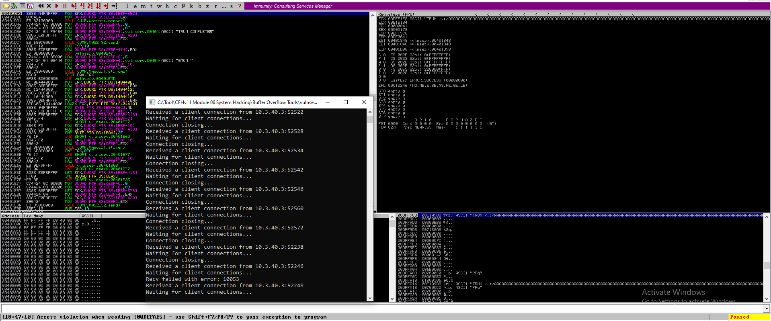

Image 6.1.7.5.3 Status changes from Running to Paused

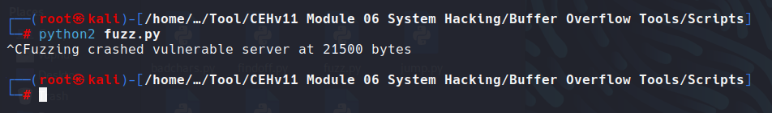

Image 6.1.7.5.4 Terminate fuzz.py script

Task 7.6 Identify the Offset

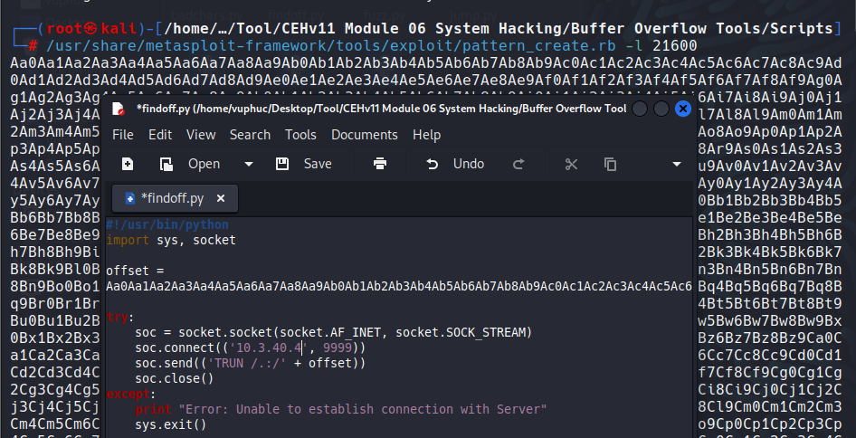

Image 6.1.7.6.1 Paste the copied random bytes

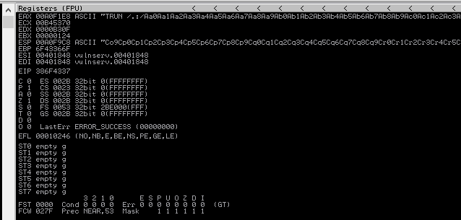

Image 6.1.7.6.2 Immunity Debugger – EIP overwritten

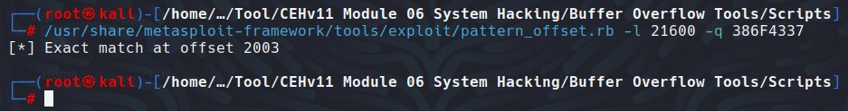

Image 6.1.7.6.3 Identified EIP register

Task 7.7 Overwrite the EIP Register

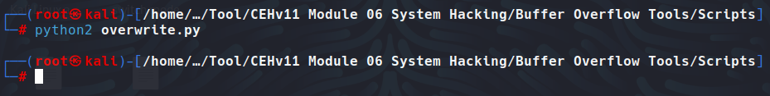

Image 6.1.7.7.1 Execute overwrite.py script

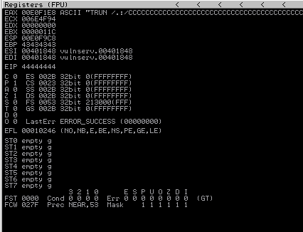

Image 6.1.7.7.2 Immunity Debugger – EIP is overwritten

Task 7.8: Identify Bad Characters

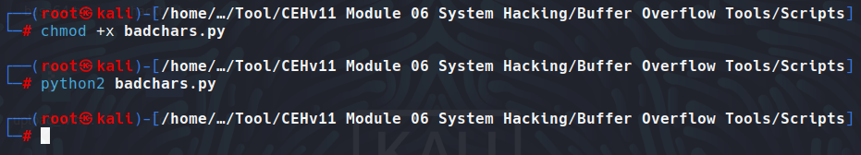Image 6.1.7.8.1 Execute badchars.py script

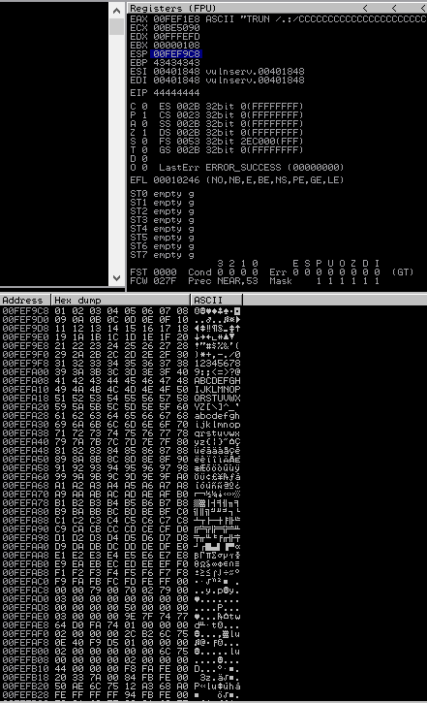

Image 6.1.7.8.2 Hex dump window

Task 7.9 Identify the Right Module

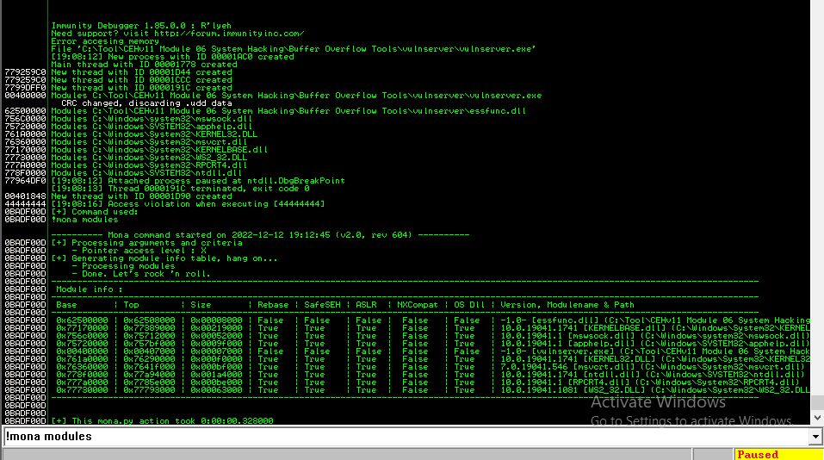

Image 6.1.7.9.1 Log data window

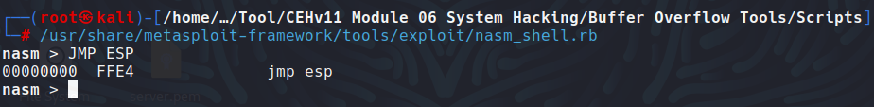

Image 6.1.7.9.2 nasm_shell script to convert asm language into hex code

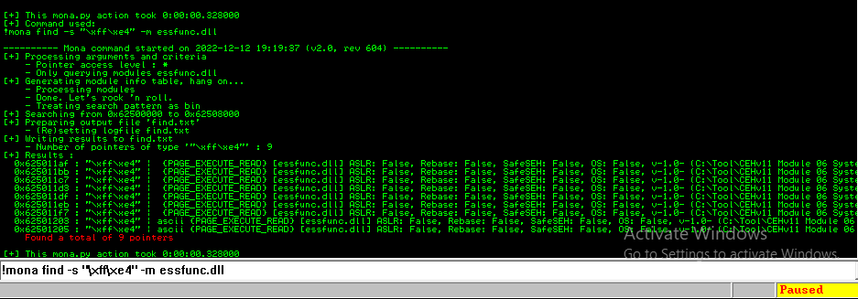

Image 6.1.7.9.3 Displaying the return address of the vulnerable module

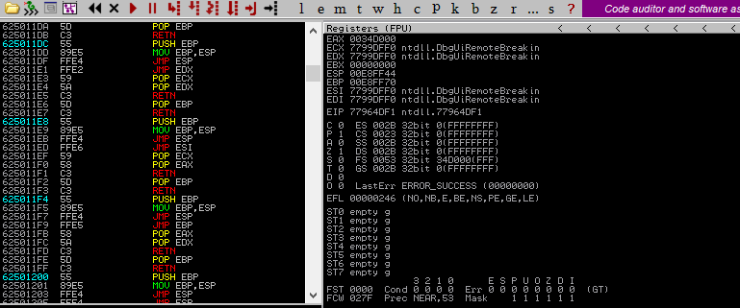

Image 6.1.7.9.4 Setting up a break point

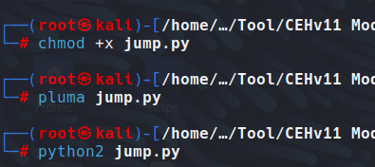

Image 6.1.7.9.5 Executing a jump.py script

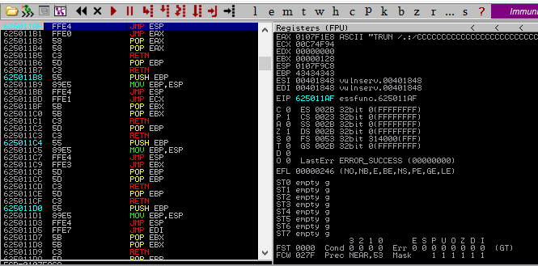

Image 6.1.7.9.6 EIP register gets iverqritten with the retuen address of a vulnerable mdule

Task 7.10: Genarate Shellcode

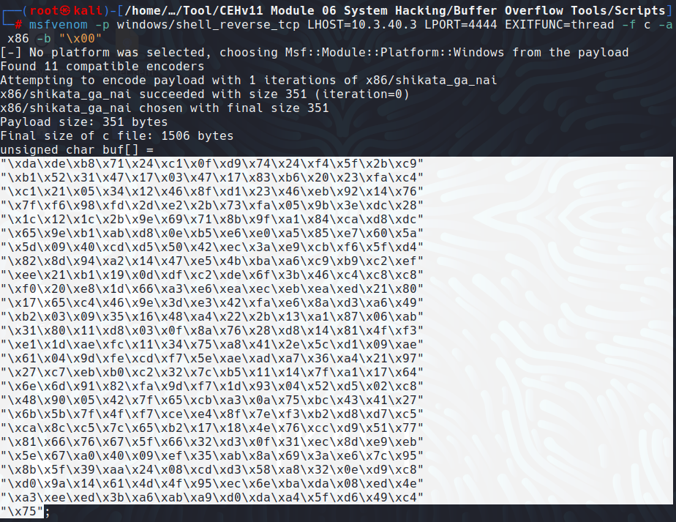

Image 6.1.7.10.1 Creating and Copying a shellcode

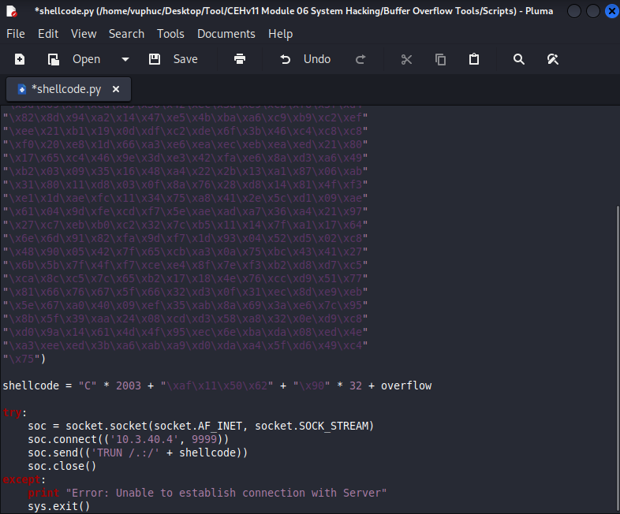

Image 6.1.7.10.2 Pasting the copied shellcode

Task 7.11 Gain Root Access

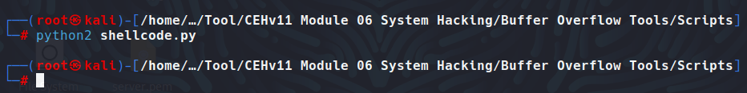

Image 6.1.7.11.1 Executing shellcode.py script

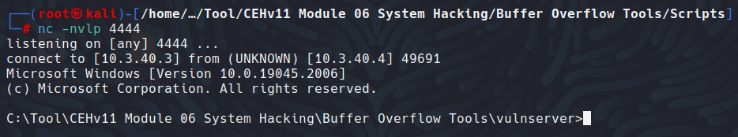

Image 6.1.7.11.2 Shell access to the target vulnerable server

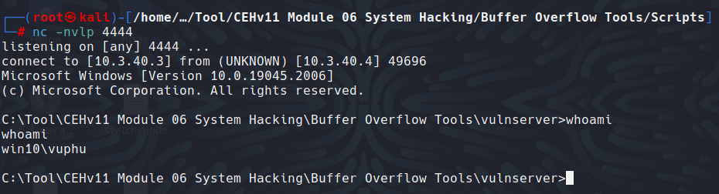

Image 6.1.7.11.3 Displaying the current username

**Module 08: Siffing**

Lab 1: Perform Active Sniffing

Task 1: Perform MAC Flooding using macof

Task 1.1: Launch Wireshark

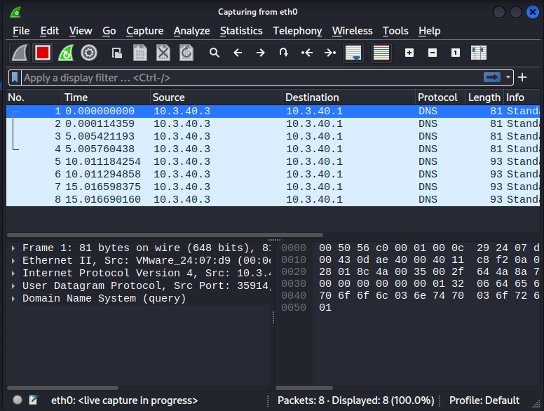

Image 8.1.1.1 Wireshark Main Window

Task 1.2: Launch MAC Flooding Attack

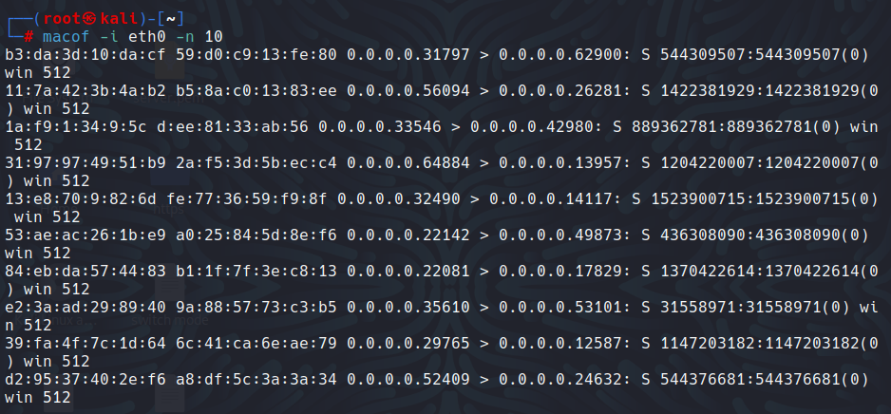

Image 8.1.1.2 Command to flood the CAM table

Task 1.3: Analyze Captured Packets

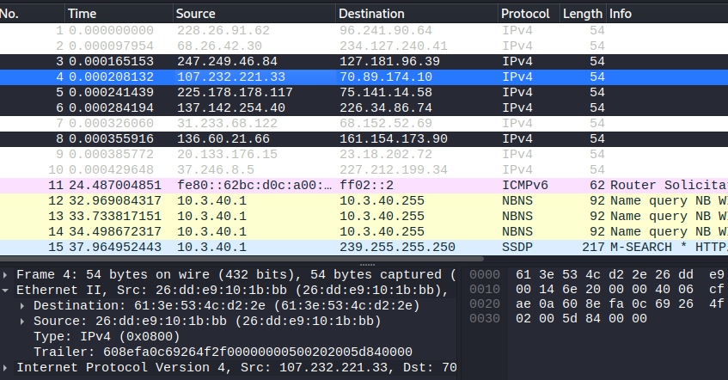

Image 8.1.1.3.1 Viewing packet content in Wireshark

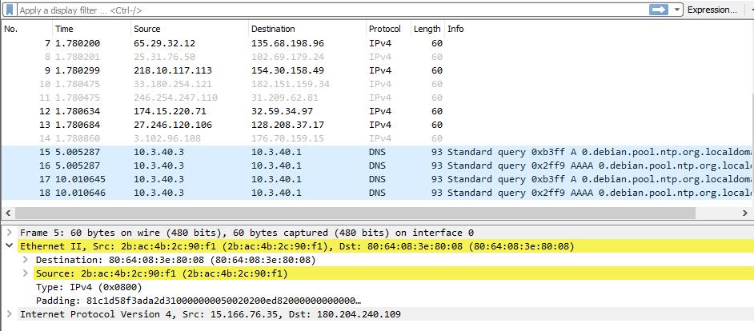

Image 8.1.1.3.2 Wireshrak captured the target machine’s packets (Windows 10)

Task 2: Perform a DHCP Starvation Attack using Yersinia

Task 2.1: Launch Wireshark

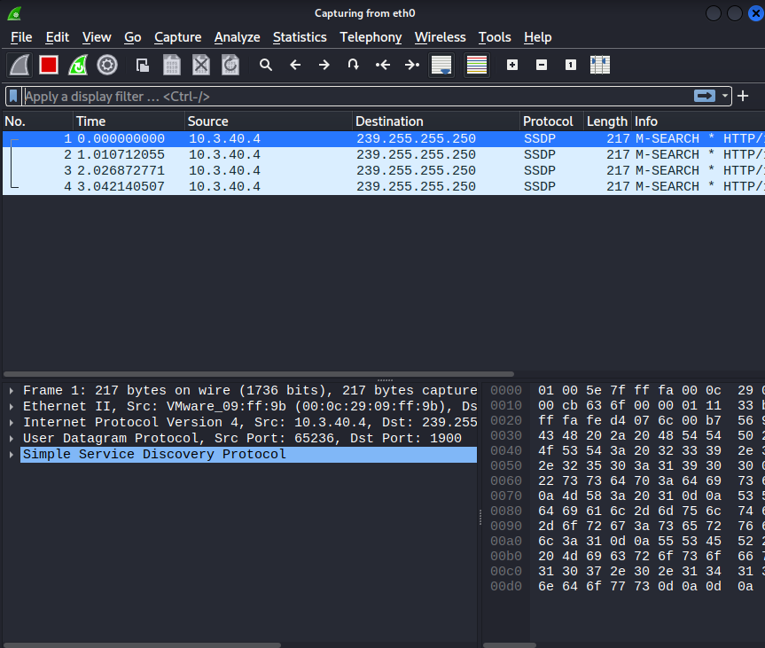

Image 8.1.2.1 Wireshark Main Window

Task 2.2: Launch and Configure Yersinia

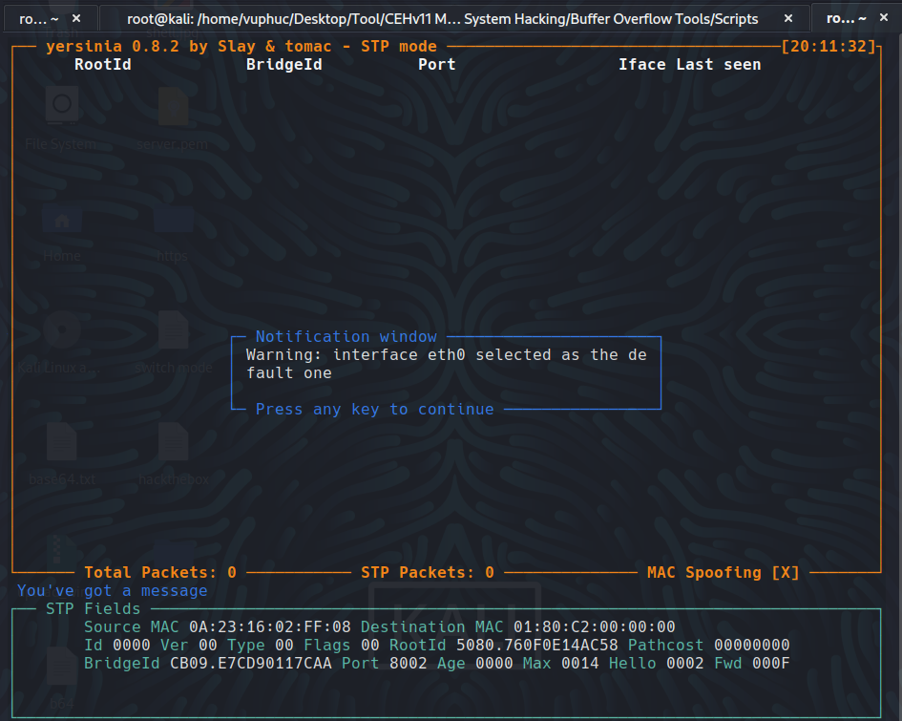

Image 8.1.2.2.1 Yersinia interactive mode

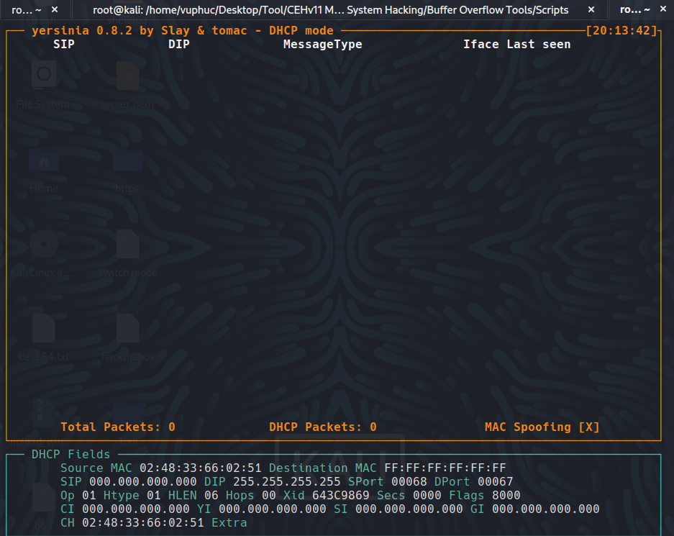

Image 8.1.2.2.2 Yersinia Execute DHCP mode

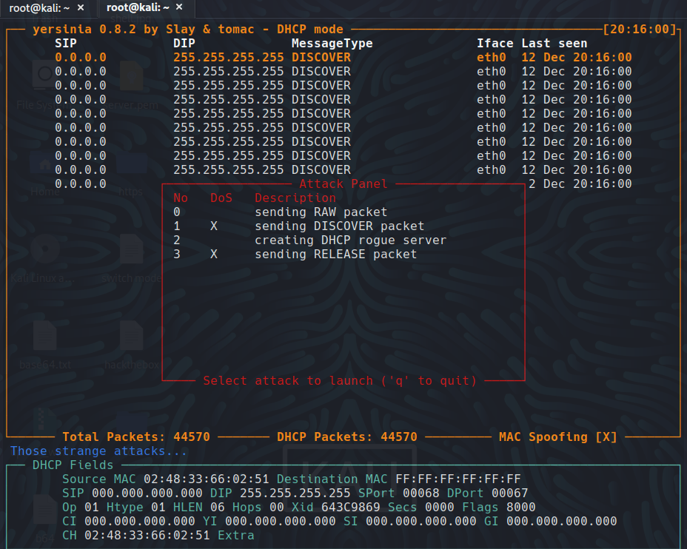

Image 8.1.2.2.3 Yersinia attack panel

Task 2.3: Launch DHCP Starvation Attack

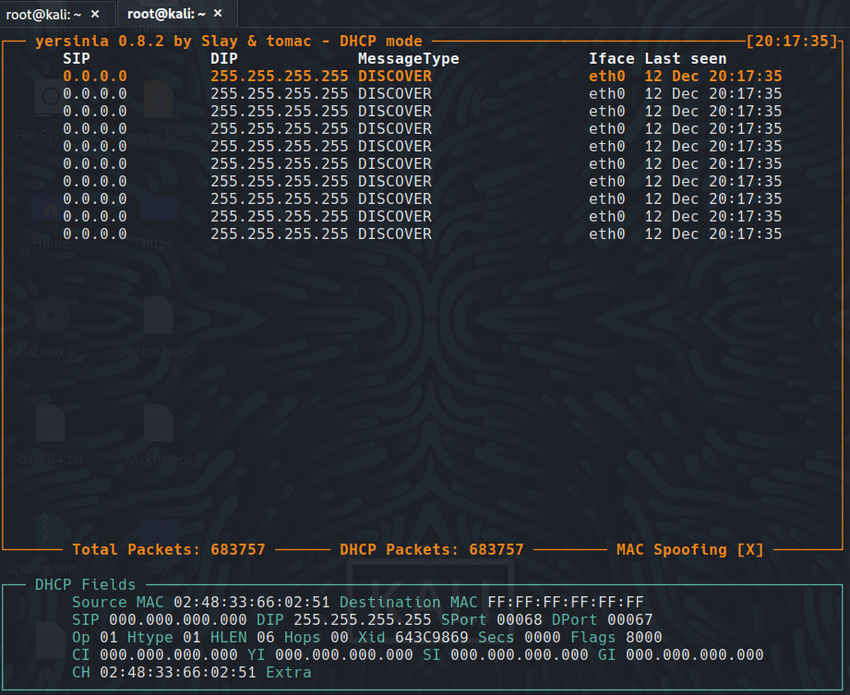

Image 8.1.2.3 Yersinia sending DHCP packets

Task 2.4: Analyze Captured Packets

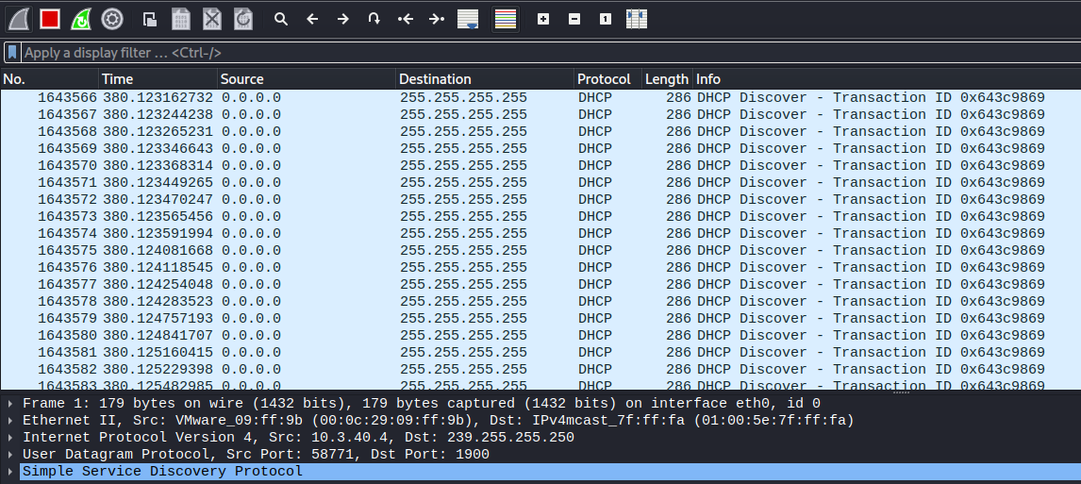

Image 8.1.2.4.1: Wireshark: DHCP packets

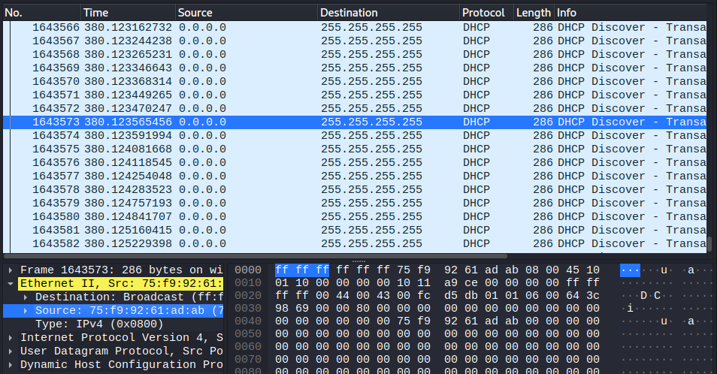

Image 8.1.2.4.2: Viewing packet content

Lab 2: Perform Network Sniffing using Various Sniffing Tools

Task 1: Perform Password Sniffing using Wireshark

Task 1.1: Launch Wireshark

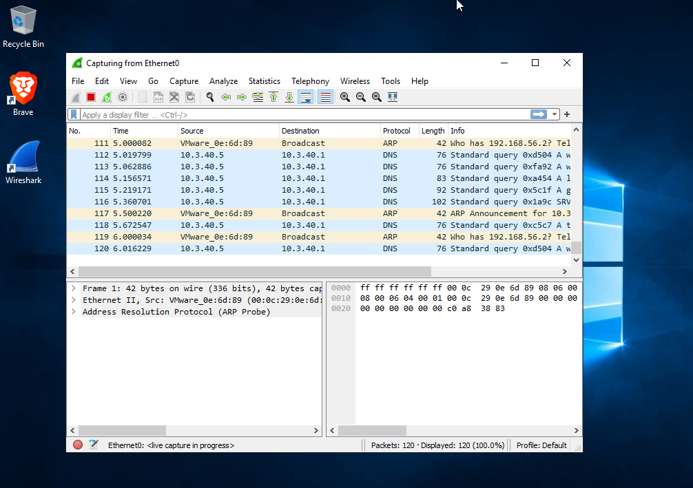

Image 8.2.1.1 Wireshark Window

Task 1.2: Open Moviescope Website and Login

Chưa xong

Lab 3: Detect Network Sniffing

Task 1: Detect ARP Poisoning in a SwitchBased Network

Task 1.1: Launch and Configure Cain & Abel

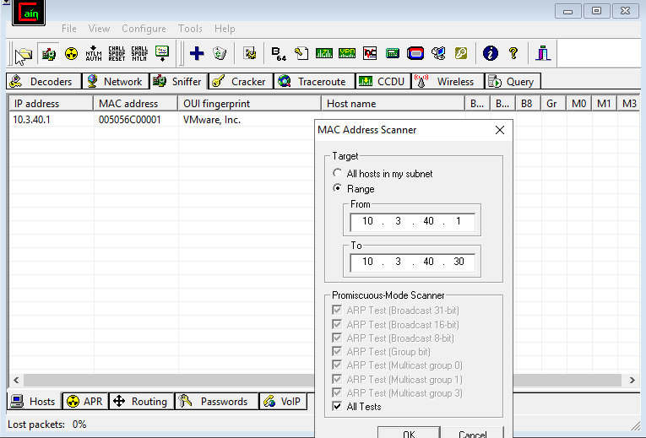

Image 8.3.1.1.1 Cain & Abel: MAC Address Scanner Window

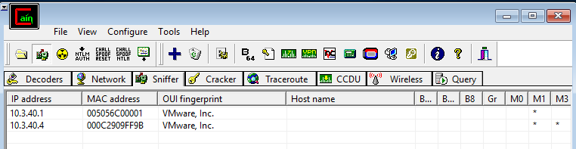

Image 8.3.1.1.2 Cain & Abel: MAC Address Scanner

Task 1.2: Perform ARP Poisoning

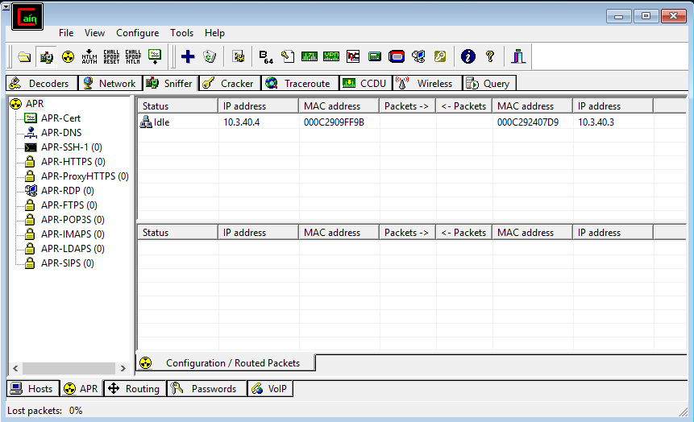

Image 8.3.1.2.1 Performing ARP Poison Routing

Task 1.3: Ping Windows 10 Machine

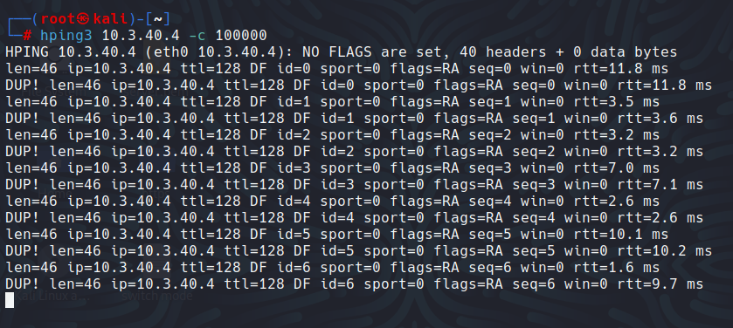

Image 8.3.1.3 Ping the target machine

Task 1.4: Dectect ARP Poisoning

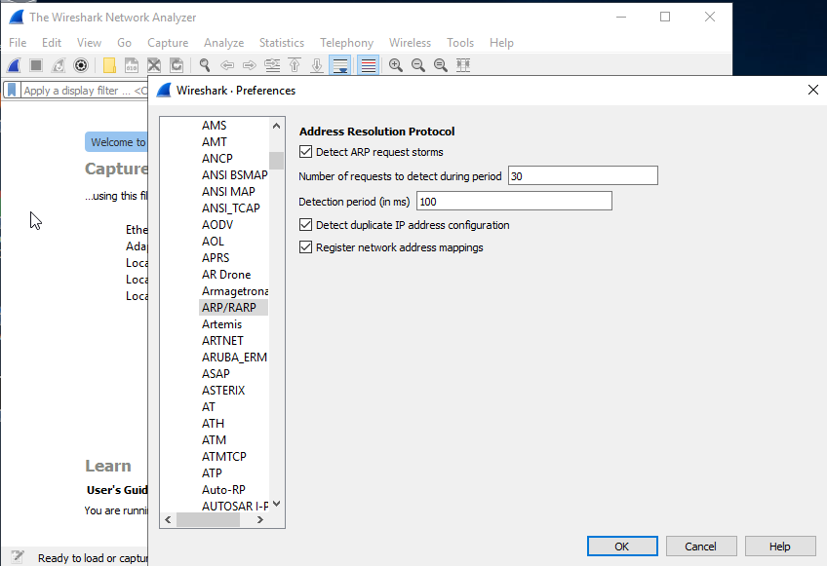

Image 8.3.1.4.1 Configuring ARP Detection Settings

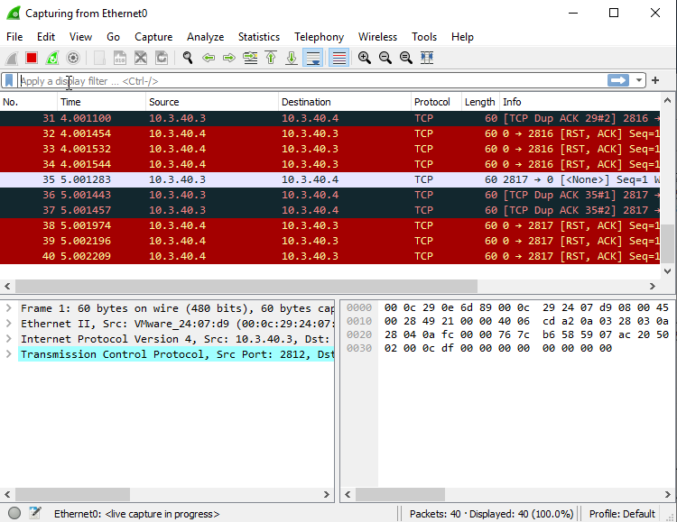

Image 8.3.1.4.2 Wireshark Capturing Packets

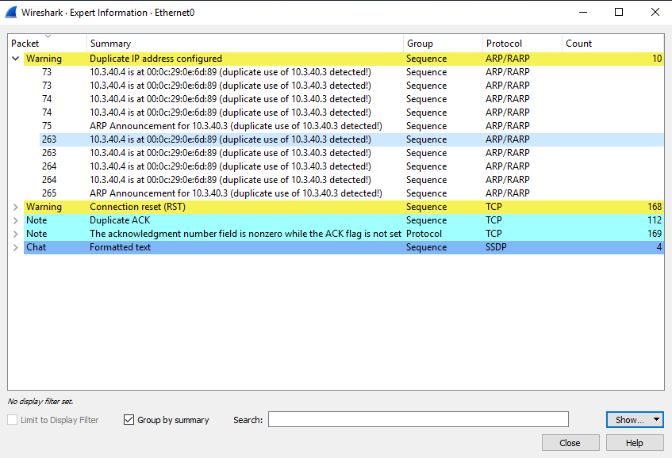

Image 8.3.1.4.3 Duplicate IP Address Detected

**Module 10: Denial-of-Service**

Lab 1: Perform DoS and DdoS Attacks using Various Techniques

Task 2: Perform a DoS Attack on a Target Host using hping3

Task 2.1: Perform SYN Flooding using hping3

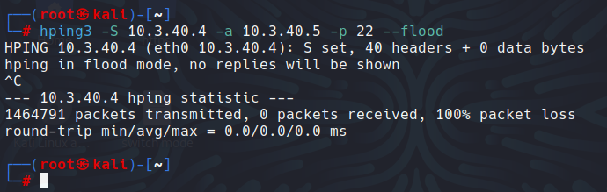

Image 10.1.2.1.1 Attack successfully launched from Kali

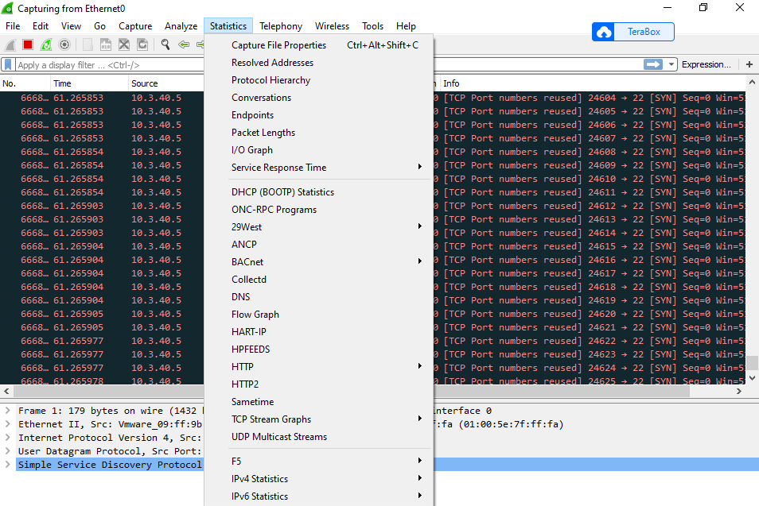

Image 10.1.2.1.2 Wireshark: I/O Graph option

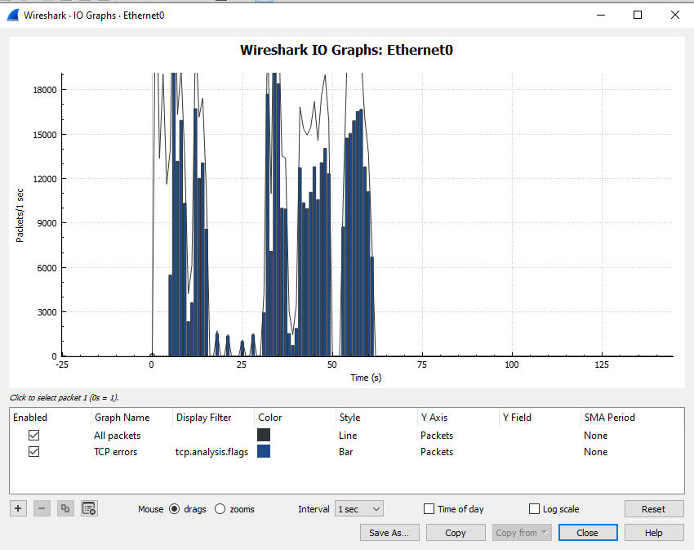

Image 10.1.2.1.3 Wireshark – IO Graphs

Task 2.2: Perform Ping of Death (PoD) Attack Using hping3

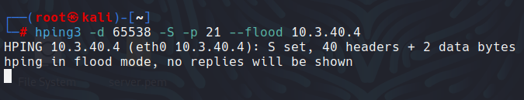

Image 10.1.2.2 Attack successfully launched from Kali

Task 2.3:

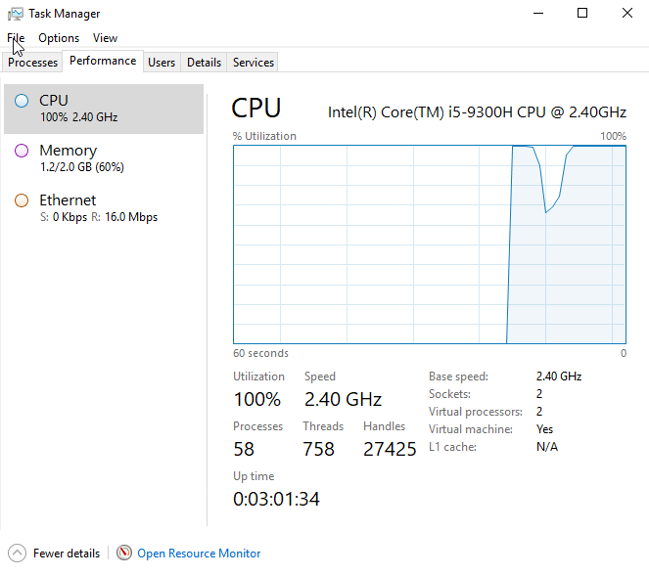

Image 10.1.2.3 erformance Tab: CPU Utilization

Task 2.4: Check for Open NetBios Port

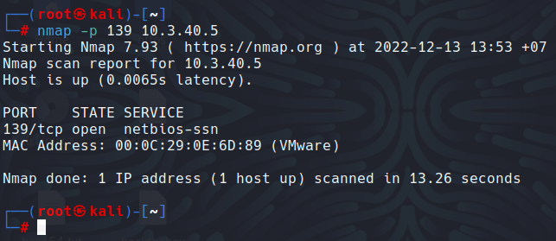

Image 10.1.2.4 Check for open port

Task 2.5: Perform UDP Application Layer Flood Attack using hping3

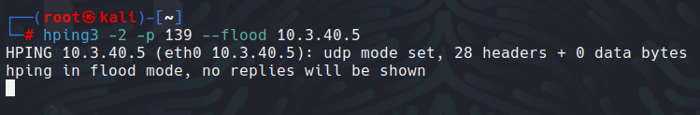

Image 10.1.2.5: Performing a UDP Application Layer Flood Attack

Task 2.6: Analyze the Network Traffic

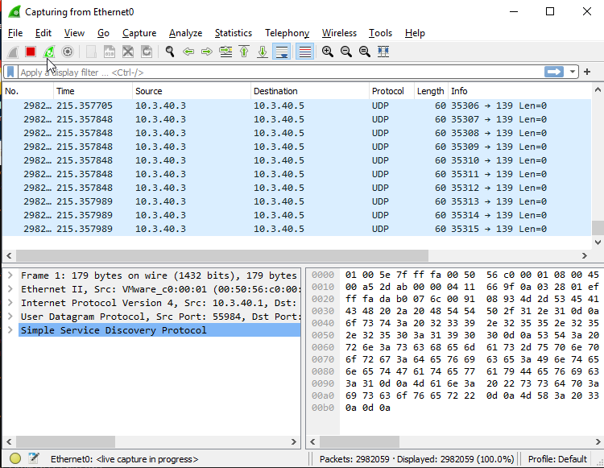

Image 10.1.2.6 Analyzing the traffic

Lab 2: Detect and Protect Against DoS and Ddos Attacks

Task 1: Detect and Protect againse DdoS Attack using Anti DdoS Guardian

Task 1.1: Install and Launch Anti DDoS Guadian

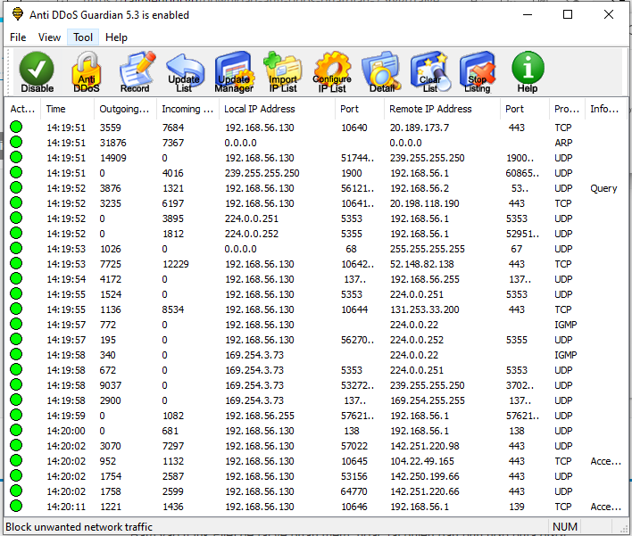

Image 10.2.1.1 Anti DDoS Guardian window

Task 1.2: Configure HOIC

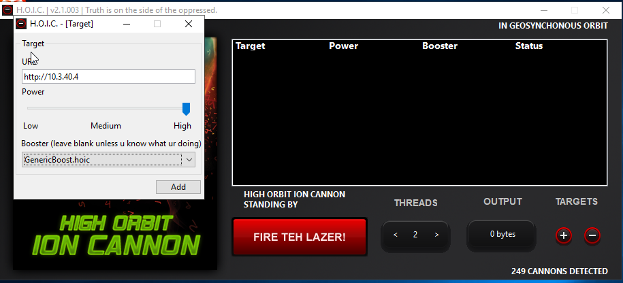

Image 10.2.1.2.1 HOIC – [Target] Pop-up

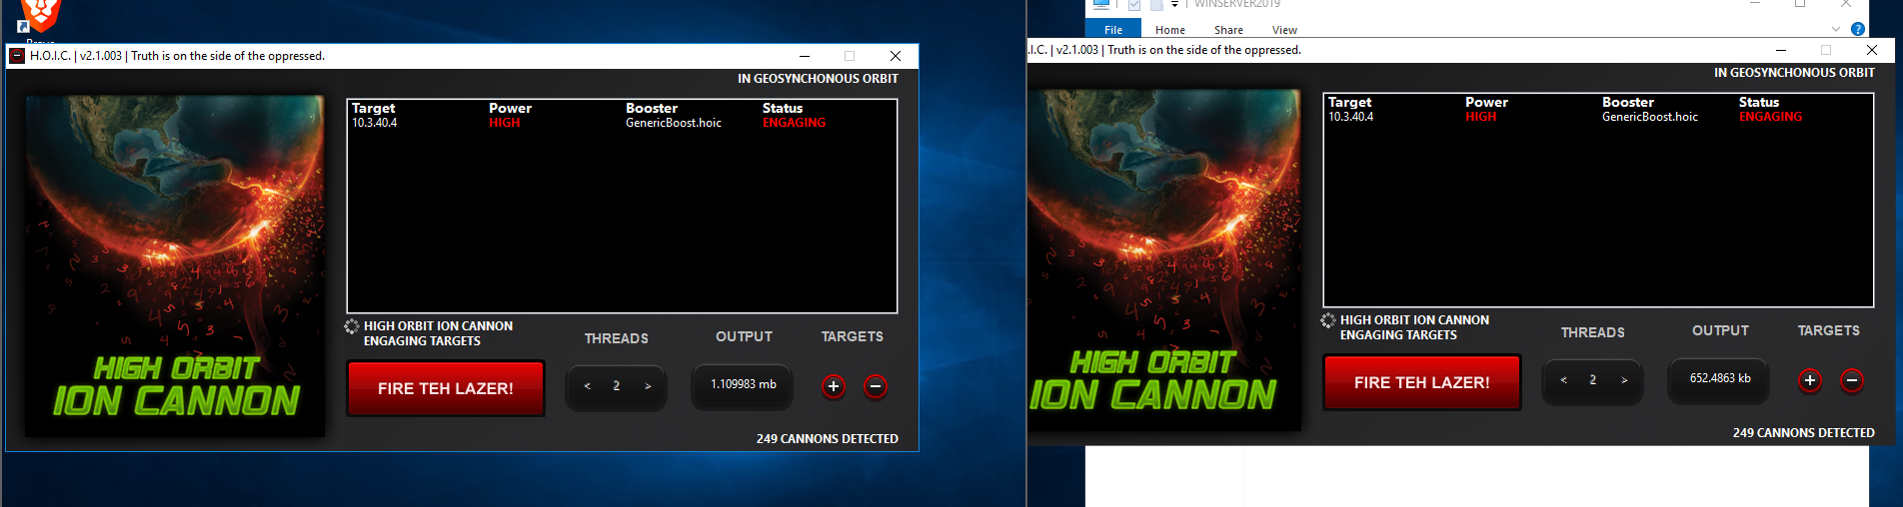

Image 10.2.1.2.2 Performing a DDoS attack on both machines

Task 1.3: Analyze Captured Sessions

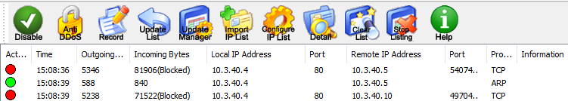

Image 10.2.1.3.1 Anti DDoS Guardian window captured sessions

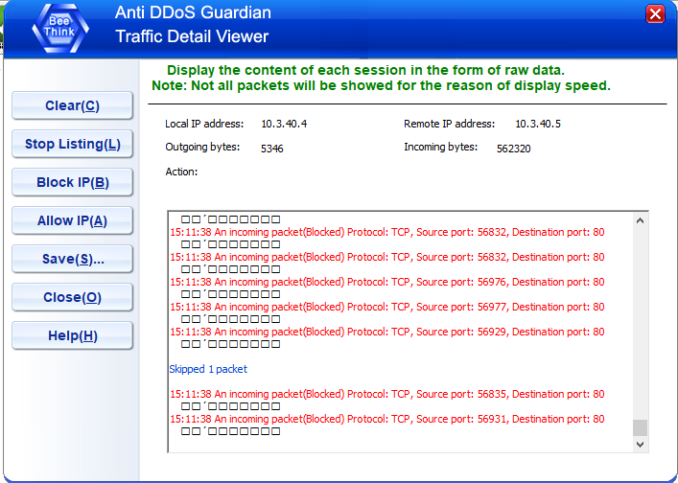

Image 10.2.1.3.2 Traffic Detatils Viewer window